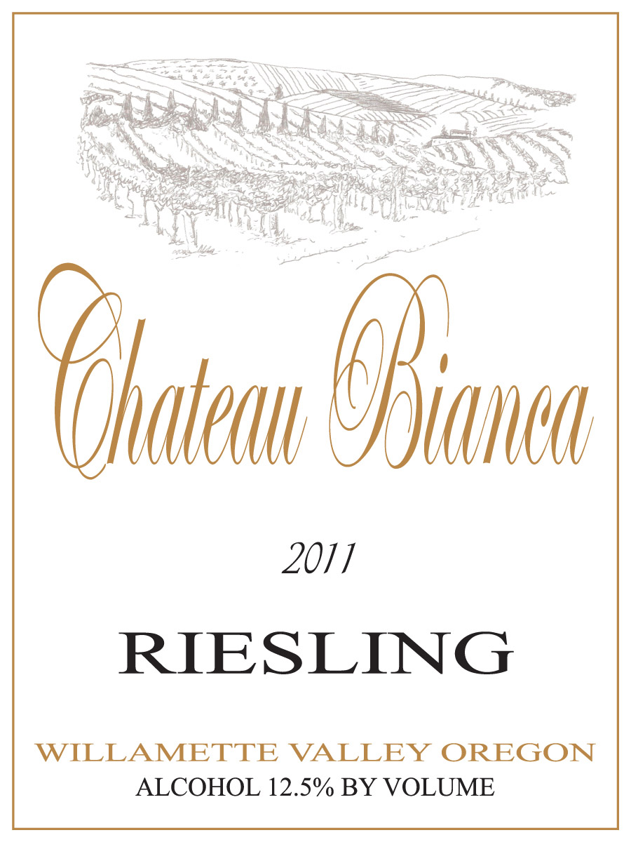
2015 Willamette Valley Riesling
Vineyard: 100% Andreas Vineyards-LIVE certified
Trellis: Upright Vertical Canopy
Canopy Management: Shoot positioning, leaf removal, use of catch-wire system
Soil Type: Willakenzie/Bellpine
Fermentation: Stainless Steel Fermentors
Temperature: 50-55 degrees F.
Yeast: 71B
Ph: 2.91
R.S.: 2.5%
Alcohol: 11.5%
Production notes: The fruit is handled very gently by pressing in our state of the art pneumatic membrane press. Pressure is kept to a minimum to avoid extracting harsh phenolics that can produce a course finish. Fermentation is managed over 30-40 days keeping the juice temperature cool to convert the sugar slowly which in turn captures the delicate esters of the wine.
Tasting notes: This beautiful wine has peach, apricot and nectarine character. These characters emerge on the palate and go into the finish. The crisp acid helps balance the touch of sweetness. Serve with spicy foods, dishes with fresh fruits, or chill a glass and watch the world go by.
Production: 450 cases
As of 2012 Andreas Vineyards is a L.I.V.E certified vineyard using only sustainable farming techniques to improve naturally beneficial insects, biodiversity, natural nutrient inputs in addition to protecting ground and surface water sources from contamination.

