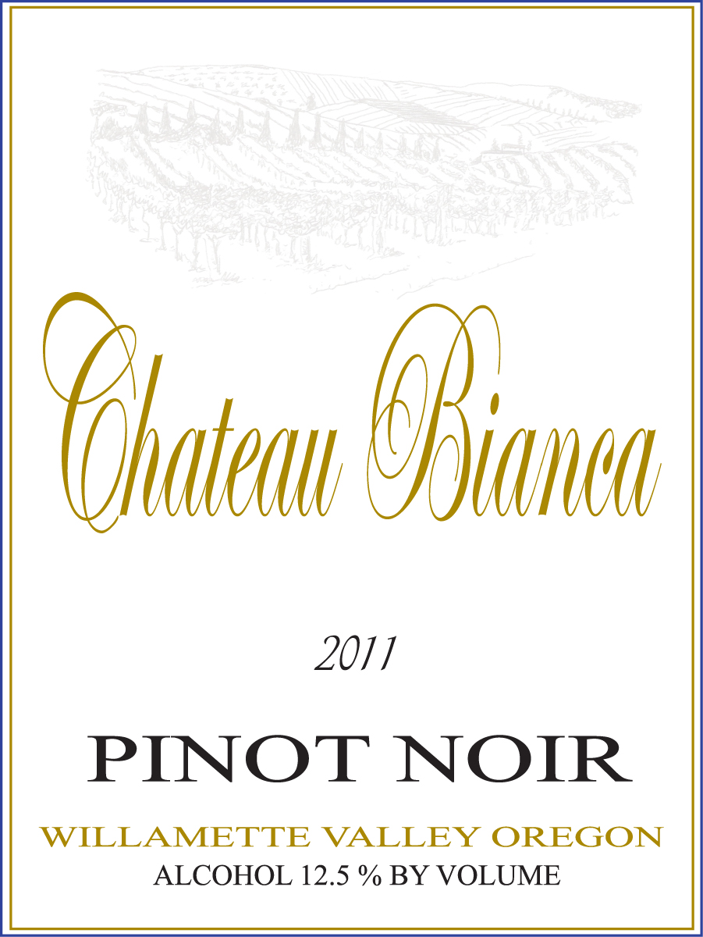
2014 Willamette Valley Pinot Noir
Vineyard: The fruit is sourced from multiple sites in the Willamette Valley
Canopy Management: Shoot positioning, leaf removal, use of catch-wire system
Soil Type: Wide range of soil types
Fermentation: Variety of different fermentation vats
Temperature: 75-95 degrees F.
Yeast: Fermented with selected yeast strains to enhance varietal character
Transfer: Using state of the art positive displacement pumps
Aging: In small French, Hungarian, and Czechoslovakian barrels for 10 months
Tasting Notes: This wine is made in a fruit forward style and intended for early consumption. The wine has delicious red fruit components of raspberry, strawberry and some stone fruit character. The wine has a soft round mouth-feel which offers up a hint of spice and a touch of bright acid to enhance a wide range of foods.
Bottling: March 2017
Alcohol: 13%
pH: 3.62
Production: 1,500 cases

